BLENDER RECIPE #6004

3 STEPS TO A DELICIOUS D’VITA SMOOTHIE
(combine all ingredients in a blender)

“BOSTON BAKED BEAN”
Makes one 16 oz. Smoothie

1. Powder: Add 1/3 cup (6 tbsp.) of Caffe D’Vita Vanilla Base Smoothie Mix. | 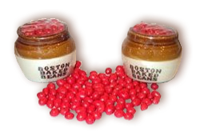
2. Mixers: Add 4 ounces of water and 1 ounce of Boston Baked Bean candies.

3. Ice: Add 12 oz. of ice and blend until smooth (about 30 seconds).

Big Finish: Top with whipped cream and crushed Boston Baked Beans!

