BLENDER RECIPE #7003

3 STEPS TO A DELICIOUS D’VITA SMOOTHIE
(combine all ingredients in a blender)

“BANANA MOCHA SPLIT”
Makes one 16 oz. Smoothie

1. Powder: Add 1/3 cup (6 tbsp.) of Caffe D’Vita Chocolate Base Smoothie Mix. | 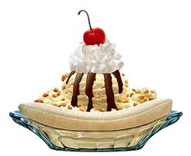
2. Mixers: Add 4 ounces of coffee, 1 ounce strawberry syrup, and 1 banana.

3. Ice: Add 12 oz. of ice and blend until smooth (about 30 seconds).

Big Finish: Top with whipped cream, crushed nuts and a cherry!

